***Outputs of the R- commands (Highlighted in bold)***

library("psych", lib.loc="~/R/win-library/3.3")

describe(Cities42)

**#Dependent Variable: RoomRent**

**#finding out the most important independent variables**

cor(RoomRent,StarRating)

**0.3693734**

cor(RoomRent,IsTouristDestination)

**0.122503**

cor(RoomRent,IsWeekend)

**0.004580134**

cor(RoomRent,IsMetroCity)

**-0.06683977**

cor(RoomRent,Airport)

**0.04965324**

cor(RoomRent,Population)

**-0.08872806**

aov(RoomRent~CityName)

**Call:**

**aov(formula = RoomRent ~ CityName)**

**Terms:**

**CityName Residuals**

**Sum of Squares 44109962789 667381793708**

**Deg. of Freedom 41 13190**

**Residual standard error: 7113.196**

**Estimated effects may be unbalanced**

summary(aov(RoomRent~CityName))

**Df Sum Sq Mean Sq F value Pr(>F)**

**CityName 41 4.411e+10 1.076e+09 21.26 <2e-16 \*\*\***

**Residuals 13190 6.674e+11 5.060e+07**

**---**

**Signif. codes: 0 ‘***’ 0.001 ‘**’ 0.01 ‘*’ 0.05 ‘.’ 0.1 ‘ ’ 1**

**#CONCLUSION - THE MOST IMPORTANT INDEPENDENT VARIABLES: StarRating , IsTouristDestination, CityName**

**Y = RoomRent**

**x1 = StarRating**

**x2 = IsTouristDestination**

**x3 = CityName**

**1. Visualizing Y, x1, x2, x3 individually.**

summary(RoomRent)

**Min. 1st Qu. Median Mean 3rd Qu. Max.**

**299 2436 4000 5474 6299 322500**

boxplot(RoomRent,main = "Room Rent Distribution")

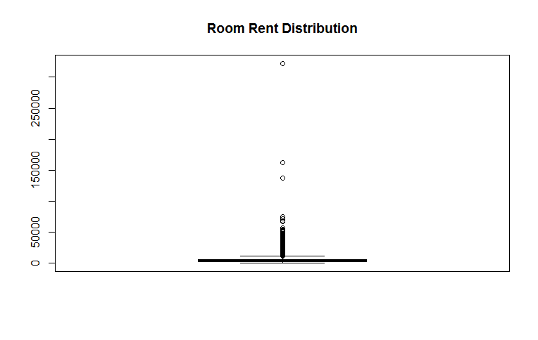

summary(StarRating)

**Min. 1st Qu. Median Mean 3rd Qu. Max.**

**0.000 3.000 3.000 3.459 4.000 5.000**

boxplot(StarRating,main = "Star Rating Distribution")

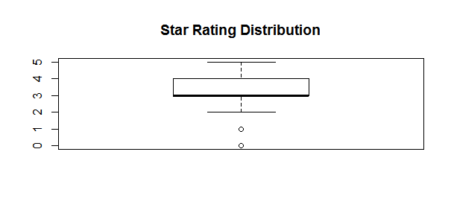

library("plyr", lib.loc="~/R/win-library/3.3")

count(Cities42,'StarRating')->FreqStarRating

**StarRating freq**

**1 0.0 16**

**2 1.0 8**

**3 2.0 440**

**4 2.5 632**

**5 3.0 5953**

**6 3.2 8**

**7 3.3 16**

**8 3.4 8**

**9 3.5 1752**

**10 3.6 8**

**11 3.7 24**

**12 3.8 16**

**13 3.9 32**

**14 4.0 2463**

**15 4.1 24**

**16 4.3 16**

**17 4.4 8**

**18 4.5 376**

**19 4.7 8**

**20 4.8 16**

**21 5.0 1408**

count(Cities42,'IsTouristDestination')->freqTouristDest

**IsTouristDestination freq**

**1 0 4007**

**2 1 9225**

count(Cities42,'CityName')->FreqCityName

**CityName freq**

**1 Agra 432**

**2 Ahmedabad 424**

**3 Amritsar 136**

**4 Bangalore 656**

**5 Bhubaneswar 120**

**6 Chandigarh 336**

**7 Chennai 416**

**8 Darjeeling 136**

**9 Delhi 2048**

**10 Gangtok 128**

**11 Goa 624**

**12 Guwahati 48**

**13 Haridwar 48**

**14 Hyderabad 536**

**15 Indore 160**

**16 Jaipur 768**

**17 Jaisalmer 264**

**18 Jodhpur 224**

**19 Kanpur 16**

**20 Kochi 608**

**21 Kolkata 512**

**22 Lucknow 128**

**23 Madurai 112**

**24 Manali 288**

**25 Mangalore 104**

**26 Mumbai 712**

**27 Munnar 328**

**28 Mysore 160**

**29 Nainital 144**

**30 Ooty 136**

**31 Panchkula 64**

**32 Pune 600**

**33 Puri 56**

**34 Rajkot 128**

**35 Rishikesh 88**

**36 Shimla 280**

**37 Srinagar 40**

**38 Surat 80**

**39 Thiruvanthipuram 392**

**40 Thrissur 32**

**41 Udaipur 456**

**42 Varanasi 264**

**#2. Visualising pair wise**

mytableSR <- xtabs(~RoomRent+StarRating)

View(mytableSR)

summary(mytableSR)

**#Call: xtabs(formula = ~RoomRent + StarRating)**

**#Number of cases in table: 13232**

**#Number of factors: 2**

**#Test for independence of all factors:**

**# Chisq = 132395, df = 43100, p-value = 0**

**#Chi-squared approximation may be incorrect**

mytableTD <- xtabs(~RoomRent+IsTouristDestination)

View(mytableTD)

summary(mytableTD)

**#Call: xtabs(formula = ~RoomRent + IsTouristDestination)**

**#Number of cases in table: 13232**

**#Number of factors: 2**

**#Test for independence of all factors:**

**# Chisq = 6413, df = 2155, p-value = 0**

**#Chi-squared approximation may be incorrect**

mytableCN <- xtabs(~RoomRent+CityName)

summary(mytableCN)

**#Call: xtabs(formula = ~RoomRent + CityName)**

**#Number of cases in table: 13232**

**#Number of factors: 2**

**#Test for independence of all factors:**

**# Chisq = 237148, df = 88355, p-value = 0**

**#Chi-squared approximation may be incorrect**

**\*\*\*\*\*\*\*\*\*\*\*\*\*\*\*\*\*\*\*\*\*\*\*\*\*\*\*\*\*\*\*\*\*\*\*\*\*\*\*\*\*\*\*\*\*\*\*\*\*\*\*\*\*\*\*\*\*\*\*\*\*\*\*\*\*\*\*\*\*\*\*\*\*\*\*\*\*\*\*\*\*\*\*\*\*\*\*\*\*\*\*\*\*\*\*\*\*\*\*\*\*\*\*\*\***

aov(RoomRent~IsTouristDestination)

**Call:**

**aov(formula = RoomRent ~ IsTouristDestination)**

**Terms:**

**IsTouristDestination Residuals**

**Sum of Squares 10677339739 700814416758**

**Deg. of Freedom 1 13230**

**Residual standard error: 7278.16**

**Estimated effects may be unbalanced**

summary(aov(RoomRent~IsTouristDestination))

**Df Sum Sq Mean Sq F value Pr(>F)**

**IsTouristDestination 1 1.068e+10 1.068e+10 201.6 <2e-16 \*\*\***

**Residuals 13230 7.008e+11 5.297e+07**

**---**

**Signif. codes: 0 ‘***’ 0.001 ‘**’ 0.01 ‘*’ 0.05 ‘.’ 0.1 ‘ ’ 1**

**\*\*\*\*\*\*\*\*\*\*\*\*\*\*\*\*\*\*\*\*\*\*\*\*\*\*\*\*\*\*\*\*\*\*\*\*\*\*\*\*\*\*\*\*\*\*\*\*\*\*\*\*\*\*\*\*\*\*\*\*\*\*\*\*\*\*\*\*\*\*\*\*\*\*\*\*\*\*\*\*\*\*\*\*\*\*\*\*\*\*\*\*\*\*\*\*\*\*\*\*\*\*\*\*\***

aov(RoomRent~StarRating)

**Call:**

**aov(formula = RoomRent ~ StarRating)**

**Terms:**

**StarRating Residuals**

**Sum of Squares 97073606828 614418149669**

**Deg. of Freedom 1 13230**

**Residual standard error: 6814.784**

**Estimated effects may be unbalanced**

summary(aov(RoomRent~StarRating))

**Df Sum Sq Mean Sq F value Pr(>F)**

**StarRating 1 9.707e+10 9.707e+10 2090 <2e-16 \*\*\***

**Residuals 13230 6.144e+11 4.644e+07**

**---**

**Signif. codes: 0 ‘***’ 0.001 ‘**’ 0.01 ‘*’ 0.05 ‘.’ 0.1 ‘ ’ 1**

**\*\*\*\*\*\*\*\*\*\*\*\*\*\*\*\*\*\*\*\*\*\*\*\*\*\*\*\*\*\*\*\*\*\*\*\*\*\*\*\*\*\*\*\*\*\*\*\*\*\*\*\*\*\*\*\*\*\*\*\*\*\*\*\*\*\*\*\*\*\*\*\*\*\*\*\*\*\*\*\*\*\*\*\*\*\*\*\*\*\*\*\*\*\*\*\*\*\*\*\*\*\*\*\*\***

**NOTE: AS CITY NAME IS A CHARACTER AND BECOMES A LITTLE DIFFICULT TO DEAL WITH, I HAVE USED CITY RANK INSTEAD OF CITY NAME**

**Draw Scatter Plots to understand how are the variables correlated pair-wise**

ggplot(Cities42, aes(x = CityRank, y = RoomRent)) +

geom_point(position = position_dodge(width = 0.4))

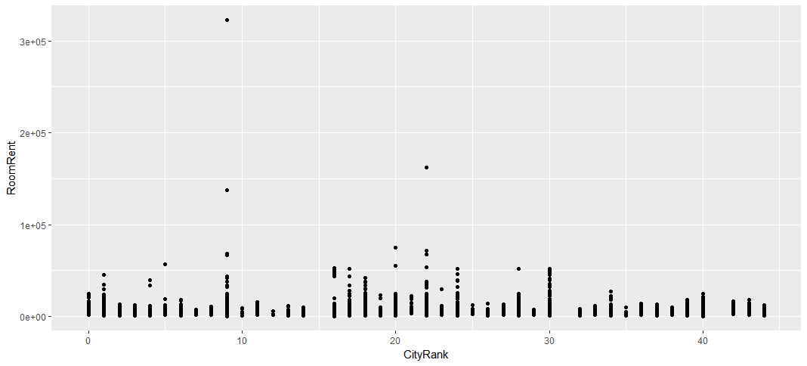

ggplot(Cities42, aes(x = IsTouristDestination, y = RoomRent)) +

geom_point(position = position_dodge(width = 0.4))

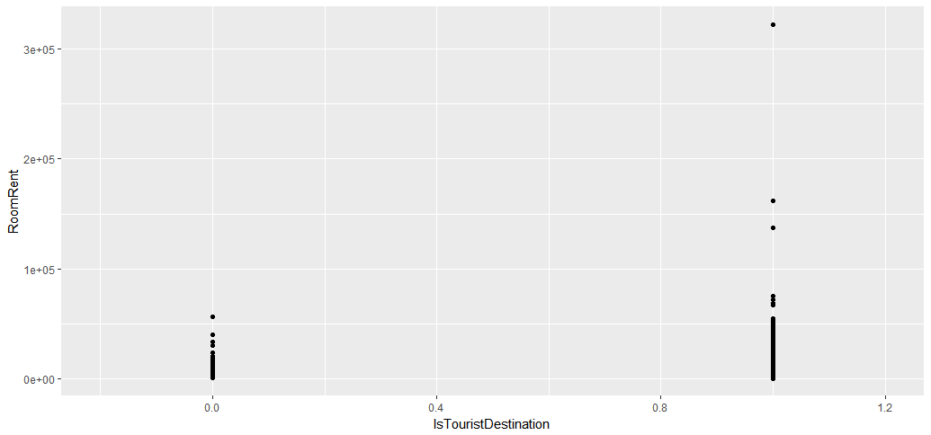

ggplot(Cities42, aes(x = StarRating, y = RoomRent)) +

geom_point(position = position_dodge(width = 0.4))

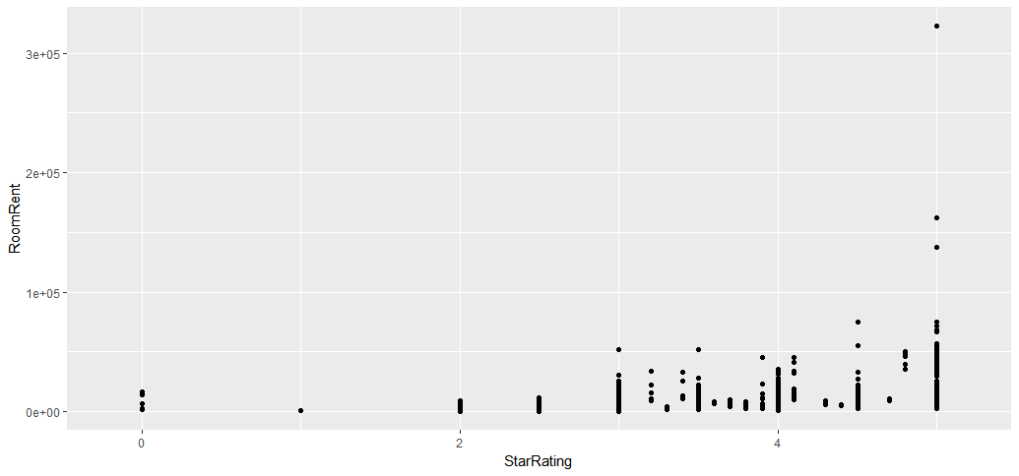

Data<-NULL

Data <- cbind(Data,CityName,IsTouristDestination,RoomRent,StarRating)

Data <- as.data.frame(Data)

**Create a Variance-Covariance Matrix for Y, x1, x2, x3**

corrplot(corr=cor(Cities42[,c(3,5,10,11)], use="complete.obs"),

method ="ellipse",align = "center")

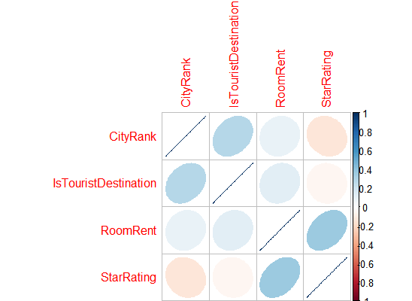

corr=cor(Cities42[,c(3,5,10,11)], use="complete.obs")

**CityRank IsTouristDestination RoomRent StarRating**

**CityRank 1.00000000 0.2807135 0.09398553 -0.1333810**

**IsTouristDestination 0.28071345 1.0000000 0.12250296 -0.0405550**

**RoomRent 0.09398553 0.1225030 1.00000000 0.3693734**

**StarRating -0.13338101 -0.0405550 0.36937343 1.0000000**

**Draw a Corrgram of Y, x1, x2, x3 (Ignore other variables for now)**

corrgram(Cities42[,c(3,5,10,11)],upper.panel=panel.pie, text.panel=panel.txt,

main="Hotel Room Rent")

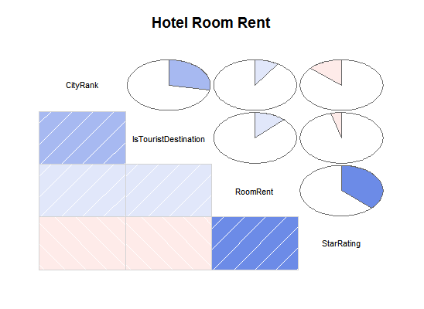

**#Aggregate functions for finding means and sd**

aggregate(Cities42$RoomRent , by=list(isTD = Cities42$IsTouristDestination), mean)

**isTD x**

**1 0 4111.003**

**2 1 6066.024**

aggregate(Cities42$RoomRent , by=list(isTD = Cities42$IsTouristDestination), sd)

**isTD x**

**1 0 3037.830**

**2 1 8483.476**

aggregate(Cities42$RoomRent , by=list(isTD = Cities42$StarRating), mean)

**isTD x**

**1 0.0 7237.125**

**2 1.0 686.625**

**3 2.0 2783.166**

**4 2.5 2520.816**

**5 3.0 3694.811**

**6 3.2 15937.500**

**7 3.3 2841.062**

**8 3.4 23437.500**

**9 3.5 4843.346**

**10 3.6 7769.500**

**11 3.7 6701.958**

**12 3.8 5400.062**

**13 3.9 13062.750**

**14 4.0 6393.105**

**15 4.1 19075.000**

**16 4.3 7423.125**

**17 4.4 5563.500**

**18 4.5 8699.920**

**19 4.7 10125.000**

**20 4.8 46752.812**

**21 5.0 12398.221**

aggregate(Cities42$RoomRent , by=list(isTD = Cities42$StarRating), sd)

**isTD x**

**1 0.0 6303.4146**

**2 1.0 202.3617**

**3 2.0 1805.5577**

**4 2.5 1727.1692**

**5 3.0 2864.0726**

**6 3.2 8561.4898**

**7 3.3 1216.5358**

**8 3.4 9688.1279**

**9 3.5 3141.5313**

**10 3.6 971.2188**

**11 3.7 2049.8067**

**12 3.8 1788.0045**

**13 3.9 12445.5317**

**14 4.0 4397.0254**

**15 4.1 9281.4097**

**16 4.3 1481.0929**

**17 4.4 371.5962**

**18 4.5 9602.0364**

**19 4.7 566.9467**

**20 4.8 5069.4339**

**21 5.0 17098.6651**

**#fitting a linear model**

xtabs(RoomRent~CityName+Airport+IsTouristDestination+StarRating,data = Cities42)->mytable3

mytable3<-as.data.frame(mytable3)

names(mytable3)<-c("CityName","Airport","IsTd","StarRating","Price")

mytable3<-as.data.frame(mytable3[mytable3$Price!= 0 ,])

fit<-lm(Price~CityName+Airport+IsTd+StarRating,data = mytable3)

summary(fit)

**Call:**

**lm(formula = Price ~ CityName + Airport + IsTd + StarRating,**

**data = mytable3)**

**Residuals:**

**Min 1Q Median 3Q Max**

**-285805 -23130 -755 12764 818496**

**Coefficients: (5 not defined because of singularities)**

**Estimate Std. Error t value Pr(>|t|)**

**(Intercept) 44169.1 81582.2 0.541 0.588373**

**CityNameAhmedabad -3979.7 22965.6 -0.173 0.862468**

**CityNameAmritsar 7358.6 25743.0 0.286 0.775065**

**CityNameBangalore -6356.7 24950.2 -0.255 0.798960**

**CityNameBhubaneswar 1434.6 29109.4 0.049 0.960705**

**CityNameChandigarh -17559.8 23053.4 -0.762 0.446453**

**CityNameChennai -8203.7 20366.9 -0.403 0.687204**

**CityNameDarjeeling 3688.0 28730.7 0.128 0.897891**

**CityNameDelhi 13045.3 14180.9 0.920 0.357883**

**CityNameGangtok 164456.9 65576.1 2.508 0.012336 \***

**CityNameGoa 51046.6 16955.4 3.011 0.002686 \*\***

**CityNameGuwahati -16184.2 33751.8 -0.480 0.631704**

**CityNameHaridwar -14529.3 36710.6 -0.396 0.692369**

**CityNameHyderabad 759.0 25217.0 0.030 0.975996**

**CityNameIndore -6759.6 31197.4 -0.217 0.828517**

**CityNameJaipur 30841.1 14895.2 2.071 0.038710 \***

**CityNameJaisalmer 21059.9 23154.1 0.910 0.363321**

**CityNameJodhpur 43402.1 19649.4 2.209 0.027460 \***

**CityNameKanpur 4583.2 62056.7 0.074 0.941144**

**CityNameKochi 30612.3 18275.5 1.675 0.094302 .**

**CityNameKolkata -15781.3 19277.0 -0.819 0.413214**

**CityNameLucknow 4630.2 29152.8 0.159 0.873846**

**CityNameMadurai -8574.8 32592.7 -0.263 0.792547**

**CityNameManali -3989.6 23254.1 -0.172 0.863822**

**CityNameMangalore 8483.1 33582.3 0.253 0.800635**

**CityNameMumbai 38707.1 15677.9 2.469 0.013753 \***

**CityNameMunnar 17408.3 86208.7 0.202 0.840019**

**CityNameMysore -15227.4 30809.5 -0.494 0.621265**

**CityNameNainital 43255.6 123715.9 0.350 0.726700**

**CityNameOoty 245464.9 65576.1 3.743 0.000194 \*\*\***

**CityNamePanchkula -4470.7 36816.0 -0.121 0.903377**

**CityNamePune -5007.6 22576.7 -0.222 0.824523**

**CityNamePuri -100928.7 98393.5 -1.026 0.305301**

**CityNameRajkot -7774.6 30122.7 -0.258 0.796396**

**CityNameRishikesh 344.9 42239.1 0.008 0.993486**

**CityNameShimla 10005.2 32004.6 0.313 0.754650**

**CityNameSrinagar 8210.6 42778.2 0.192 0.847841**

**CityNameSurat -15005.8 36203.6 -0.414 0.678627**

**CityNameThiruvanthipuram 22572.5 17554.9 1.286 0.198863**

**CityNameThrissur -45340.8 101840.9 -0.445 0.656283**

**CityNameUdaipur 26470.2 21627.7 1.224 0.221335**

**CityNameVaranasi 61790.3 21151.8 2.921 0.003581 \*\***

**Airport0.3 3909.2 70158.1 0.056 0.955579**

**Airport0.4 13900.0 65615.5 0.212 0.832284**

**Airport0.5 -2255.1 70009.7 -0.032 0.974311**

**Airport0.6 31227.9 70551.3 0.443 0.658151**

**Airport0.7 -6420.2 70099.7 -0.092 0.927048**

**Airport0.8 -5802.8 84987.3 -0.068 0.945581**

**Airport0.9 -3388.4 58996.4 -0.057 0.954213**

**Airport1 -439.2 60520.3 -0.007 0.994211**

**Airport1.1 219040.5 71031.1 3.084 0.002112 \*\***

**Airport1.2 6760.9 64045.6 0.106 0.915955**

**Airport1.4 59749.3 85164.5 0.702 0.483141**

**Airport1.5 -45329.3 70527.0 -0.643 0.520581**

**Airport1.6 8074.4 61043.2 0.132 0.894800**

**Airport1.7 -38554.1 64889.2 -0.594 0.552571**

**Airport1.8 -10588.9 56618.9 -0.187 0.851690**

**Airport1.9 -20279.4 58648.4 -0.346 0.729596**

**Airport2 42534.5 61814.9 0.688 0.491586**

**Airport2.1 -20080.7 61788.6 -0.325 0.745271**

**Airport2.2 297.9 65297.9 0.005 0.996361**

**Airport2.3 -45678.5 70874.5 -0.644 0.519430**

**Airport2.4 -16653.6 60783.9 -0.274 0.784169**

**Airport2.5 14467.4 56664.8 0.255 0.798543**

**Airport2.6 -3001.5 59206.1 -0.051 0.959580**

**Airport2.7 -1935.0 56840.2 -0.034 0.972852**

**Airport2.8 17184.9 65262.3 0.263 0.792369**

**Airport2.9 4811.3 58312.6 0.083 0.934263**

**Airport3 -22672.9 57483.7 -0.394 0.693370**

**Airport3.1 -21966.2 70591.9 -0.311 0.755749**

**Airport3.2 9372.9 64909.2 0.144 0.885220**

**Airport3.3 935.5 69797.1 0.013 0.989309**

**Airport3.4 -11816.6 57696.6 -0.205 0.837775**

**Airport3.5 8353.7 58228.3 0.143 0.885958**

**Airport3.6 21878.6 58209.0 0.376 0.707115**

**Airport3.7 -16948.1 70579.5 -0.240 0.810290**

**Airport3.8 -2469.6 59652.7 -0.041 0.966988**

**Airport3.9 -38033.5 60552.8 -0.628 0.530108**

**Airport4 -25410.5 56945.8 -0.446 0.655554**

**Airport4.1 -28244.2 61877.2 -0.456 0.648181**

**Airport4.2 -18373.0 59581.5 -0.308 0.757880**

**Airport4.3 -26824.5 61668.4 -0.435 0.663690**

**Airport4.4 -29295.3 61728.7 -0.475 0.635210**

**Airport4.5 13315.6 69682.1 0.191 0.848501**

**Airport4.6 -4537.6 59609.9 -0.076 0.939341**

**Airport4.7 -46010.6 68061.9 -0.676 0.499222**

**Airport4.8 6984.3 61799.5 0.113 0.910046**

**Airport4.9 -32590.7 61456.5 -0.530 0.596042**

**Airport5 -14357.6 56590.3 -0.254 0.799782**

**Airport5.1 -2944.5 55916.5 -0.053 0.958017**

**Airport5.2 -22652.3 56020.8 -0.404 0.686056**

**Airport5.3 -18619.9 62025.5 -0.300 0.764101**

**Airport5.4 2161.4 60359.2 0.036 0.971443**

**Airport5.5 -5297.9 58554.6 -0.090 0.927930**

**Airport5.6 -29886.3 59693.8 -0.501 0.616743**

**Airport5.7 5782.0 61605.3 0.094 0.925247**

**Airport5.8 -16161.4 57193.9 -0.283 0.777576**

**Airport5.9 -11075.4 59556.0 -0.186 0.852516**

**Airport6 -28425.5 59614.1 -0.477 0.633612**

**Airport6.1 -99.9 61900.7 -0.002 0.998713**

**Airport6.2 -4562.4 58288.8 -0.078 0.937630**

**Airport6.3 -19882.5 70430.7 -0.282 0.777785**

**Airport6.4 -6012.9 58396.4 -0.103 0.918014**

**Airport6.5 -8254.9 58432.9 -0.141 0.887689**

**Airport6.6 7247.1 61489.3 0.118 0.906207**

**Airport6.7 -13629.8 64721.7 -0.211 0.833259**

**Airport6.8 -13742.8 58311.5 -0.236 0.813740**

**Airport6.9 -5341.6 59758.8 -0.089 0.928796**

**Airport7 1747.5 57707.2 0.030 0.975849**

**Airport7.1 -9008.5 57304.1 -0.157 0.875121**

**Airport7.2 -6174.4 58300.0 -0.106 0.915682**

**Airport7.3 21033.5 70950.1 0.296 0.766958**

**Airport7.4 -7244.0 59508.3 -0.122 0.903142**

**Airport7.5 10149.2 58221.2 0.174 0.861655**

**Airport7.6 -11690.9 56597.3 -0.207 0.836403**

**Airport7.7 157160.8 58325.3 2.695 0.007191 \*\***

**Airport7.8 14870.5 64730.4 0.230 0.818359**

**Airport7.9 -14131.5 56575.7 -0.250 0.802819**

**Airport8 61983.7 57413.9 1.080 0.280637**

**Airport8.1 32677.9 61967.4 0.527 0.598099**

**Airport8.2 -23993.4 58406.4 -0.411 0.681325**

**Airport8.3 24463.0 61901.1 0.395 0.692800**

**Airport8.4 5500.5 59913.4 0.092 0.926874**

**Airport8.5 4408.9 58425.6 0.075 0.939865**

**Airport8.6 -16720.7 86208.7 -0.194 0.846258**

**Airport8.7 7618.4 57500.8 0.132 0.894627**

**Airport8.8 -7595.9 71545.9 -0.106 0.915474**

**Airport8.9 5330.5 70644.2 0.075 0.939871**

**Airport9 -4561.0 58494.3 -0.078 0.937868**

**Airport9.1 2304.5 65929.4 0.035 0.972124**

**Airport9.2 28975.1 56929.6 0.509 0.610912**

**Airport9.3 -19412.5 58196.5 -0.334 0.738790**

**Airport9.4 12895.2 58278.5 0.221 0.824938**

**Airport9.5 -485.1 65103.0 -0.007 0.994057**

**Airport9.6 2639.4 59867.4 0.044 0.964845**

**Airport9.7 -5968.2 65080.1 -0.092 0.926954**

**Airport9.8 -16134.4 59821.5 -0.270 0.787451**

**Airport9.9 -2223.7 57360.2 -0.039 0.969086**

**Airport10 9272.2 52512.4 0.177 0.859888**

**Airport10.2 -9027.8 90973.6 -0.099 0.920976**

**Airport10.3 -8282.8 88421.0 -0.094 0.925390**

**Airport10.4 -10210.8 88421.0 -0.115 0.908093**

**Airport10.6 -5468.2 89701.7 -0.061 0.951405**

**Airport10.7 -536.0 85677.7 -0.006 0.995010**

**Airport10.8 -7634.6 85660.6 -0.089 0.929003**

**Airport10.9 -7922.6 73056.3 -0.108 0.913669**

**Airport11 33742.7 52086.3 0.648 0.517278**

**Airport11.1 27812.8 89701.7 0.310 0.756595**

**Airport11.3 -7930.6 73056.3 -0.109 0.913583**

**Airport11.7 -24184.0 85677.7 -0.282 0.777809**

**Airport11.9 40380.1 75681.5 0.534 0.593794**

**Airport12 9236.2 52475.5 0.176 0.860329**

**Airport12.2 17684.0 68310.2 0.259 0.795793**

**Airport12.3 41470.2 90648.2 0.457 0.647442**

**Airport12.6 10506.5 66078.0 0.159 0.873707**

**Airport12.7 -21725.7 74164.2 -0.293 0.769641**

**Airport13 16374.1 52351.3 0.313 0.754531**

**Airport13.1 11421.2 88421.0 0.129 0.897256**

**Airport13.3 25382.0 90425.0 0.281 0.779013**

**Airport13.5 -3413.2 89701.7 -0.038 0.969656**

**Airport13.6 14868.0 70665.3 0.210 0.833407**

**Airport13.7 9682.5 70665.3 0.137 0.891049**

**Airport13.8 1996.8 89701.7 0.022 0.982246**

**Airport14 20279.7 52903.7 0.383 0.701572**

**Airport14.2 -10503.0 71846.3 -0.146 0.883809**

**Airport14.4 1107.2 65859.9 0.017 0.986591**

**Airport14.5 -3753.2 91709.9 -0.041 0.967366**

**Airport14.6 -13935.9 70624.3 -0.197 0.843622**

**Airport14.7 -12982.9 65282.9 -0.199 0.842412**

**Airport14.8 -24123.8 70608.8 -0.342 0.732697**

**Airport14.9 12334.2 90441.7 0.136 0.891556**

**Airport15 45007.2 52949.2 0.850 0.395566**

**Airport15.3 -19862.5 70525.1 -0.282 0.778292**

**Airport15.4 -7095.9 76264.9 -0.093 0.925893**

**Airport15.6 9151.2 90441.7 0.101 0.919430**

**Airport15.7 -29654.0 85677.7 -0.346 0.729347**

**Airport15.8 -9052.0 85677.7 -0.106 0.915884**

**Airport15.9 44579.1 90786.6 0.491 0.623534**

**Airport16 56007.7 53397.4 1.049 0.294536**

**Airport16.1 16669.8 71345.9 0.234 0.815316**

**Airport16.2 -19638.0 85677.7 -0.229 0.818763**

**Airport16.4 -24061.8 90200.1 -0.267 0.789720**

**Airport16.5 -5235.9 65334.8 -0.080 0.936146**

**Airport16.7 -9135.8 64802.8 -0.141 0.887921**

**Airport17 20796.1 53030.6 0.392 0.695046**

**Airport17.1 -17287.8 90200.1 -0.192 0.848055**

**Airport17.2 5804.1 74032.8 0.078 0.937529**

**Airport17.4 -9421.8 90441.7 -0.104 0.917055**

**Airport17.5 28927.4 72093.4 0.401 0.688340**

**Airport17.6 17936.0 90122.9 0.199 0.842298**

**Airport17.8 6525.9 73613.9 0.089 0.929381**

**Airport18 23953.0 52577.5 0.456 0.648815**

**Airport18.3 35332.0 90425.0 0.391 0.696096**

**Airport18.5 -7583.2 73438.8 -0.103 0.917782**

**Airport18.6 23192.7 86231.5 0.269 0.788028**

**Airport18.7 -21034.8 90200.1 -0.233 0.815662**

**Airport19 48531.6 53738.1 0.903 0.366728**

**Airport19.5 20496.0 90797.8 0.226 0.821465**

**Airport19.9 25612.0 90122.9 0.284 0.776336**

**Airport20 27484.9 53261.3 0.516 0.605965**

**[ reached getOption("max.print") -- omitted 133 rows ]**

**---**

**Signif. codes: 0 ‘***’ 0.001 ‘**’ 0.01 ‘*’ 0.05 ‘.’ 0.1 ‘ ’ 1**

**Residual standard error: 68360 on 830 degrees of freedom**

**Multiple R-squared: 0.4483, Adjusted R-squared: 0.2309**

**F-statistic: 2.062 on 327 and 830 DF, p-value: < 2.2e-16**